IMPLEMENTATION MULTIMEDIA DEVELOPMENT LIFE CYCLE IN INTERACTIVE MULTIMEDIA DESIGN FOR TRADITIONAL INDONESIAN MUSIC INSTRUMENTS INTRODUCTION

**Aditya I Zuhdi1, Zahrotul Mustafidah2, Muhammad R N Alam3, Safira A Irawan4**

1,2,3,4 Informatics Engineering Study Program, Faculty of Informatics, Telkom Purwokerto Institute of Technology

Email: 120102217@ittelkom-pwt.ac.id, 220102212@ittelkom-pwt.ac.id, 320102070@ittelkom-pwt.ac.id, 420102162@ittelkom-pwt.ac.id

(Received: dd mmm yyyy, Revised: dd mmm yyyy, Accepted: dd mmm yyyy)

Abstract

This research aims to address the lack of interactive multimedia-based educational information media in introducing traditional Indonesian musical instruments to the public, especially children. This problem arises because the diversity of traditional musical instruments in Indonesia has not been presented attractively in an interactive media. Therefore, this research utilizes the Multimedia Development Life Cycle (MDLC) method as a guide in designing and developing interactive multimedia. The stages of MDLC, namely Concept, Design, Material Collecting, Assembly, Testing, and Distribution, are applied to ensure that each step of system development can be well-organized. The results of alpha testing show that all features of the interactive multimedia run smoothly. Beta testing involving 36 respondents yielded a rating of 4.52 out of a scale of 5, indicating that this interactive multimedia is excellent and suitable for use as a learning media about traditional Indonesian musical instruments.

**Keywords:** *traditional musical instruments, interactive multimedia, MDLC, education, system development*

*This is an open access article under the* [*CC BY*](https://creativecommons.org/licenses/by/4.0/) *license.*



*\*Corresponding Author: Aditya I Zuhdi*

# INTRODUCTION

In the current era of digitization, we are increasingly prepared to embrace the changes brought about by rapid technological advancements. With the ever-advancing technology, we can now introduce Indonesian musical instruments using interactive media, ranging from educational informational media that incorporates local cultural elements, animations, films, and more [1]. One highly engaging way to present information is through interactive multimedia [2].

The advantage of interactive multimedia lies in its emphasis on user engagement and experience, which means users have the freedom to control the system. This arises because interactive multimedia typically comes with a variety of control features that can be operated by users, allowing them to make choices according to their preferences for the next stage in the process.

Previous research on interactive multimedia includes [3], which resulted in an Android-based educational application aimed at facilitating elementary school students in understanding traditional musical instruments typical of West Java to enhance learning interest and stimulate children's cognitive development. Subsequent research [4] yielded an interactive cultural diversity introduction game media utilizing the Multimedia Development Life Cycle method. Another study [5] produced a Learning Media Introduction to Traditional Indonesian Musical Instruments for SDN 249 Turungan Datu students, capable of presenting interactive materials and interactive musical instruments. Further research [6] resulted in a learning method media for Harapan Jaya Elementary School students, providing an engaging and beneficial learning media to introduce arts and traditional customs of the archipelago. A subsequent study [7] developed an application for introducing Javanese gamelan musical instruments.

The main focus of this research is the lack of supportive learning media to introduce traditional musical instruments as part of efforts to preserve traditional culture. Another factor contributing to the lack of learning media is the limited interest in instructional media for content delivery and the minimal use of instructional technology regarding traditional musical instruments, such as relying solely on books with static images, leading students to quickly lose interest. Based on the background description and the aforementioned issues, the research titled "Implementation of Multimedia Development Life Cycle in the Development of Interactive Multimedia for Introducing Traditional Indonesian Musical Instruments" is conducted to address these problems. Additionally, the presence of interactive multimedia as a supplementary learning tool creates diverse and engaging learning experiences.

The MDLC method consists of six stages: Concept, Design, Material Collecting, Assembly, Testing, and Distribution [8]. The main advantage of this method lies in its organized system development structure from the conceptual stage to testing. This approach allows for systematic and coordinated system development, ensuring good integration for each element throughout the development process. Thus, the multimedia application produced can undergo comprehensive testing before being deployed to users or targeted audiences in the context of this research [9].

# RESEARCH METHOD

The chosen method for this research is the Multimedia Development Life Cycle (MDLC). The MDLC method is a multimedia development model consisting of six stages: Concept, Design, Material Collecting, Assembly, Testing, and Distribution. The Multimedia Development Life Cycle can be seen in Figure 1 below.

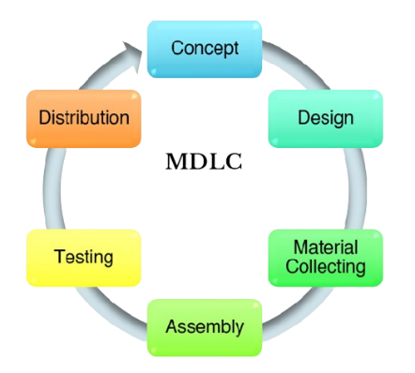

Figure 1 . The stages of MDLC

* 1. **Concept**

This stage aims to design the system by determining the system's objectives and identifying the users who will utilize the system. System requirements analysis is also conducted at this stage.

* 1. **Design**

The design stage involves creating program specifications, including material or resource requirements for the program, program interfaces, and program architecture. The design process encompasses program structure, UML design, and program design.

* 1. **Material Collecting**

This stage involves gathering the necessary materials and assets. The materials and assets collected will then be utilized in the subsequent assembly stage.

* 1. **Assembly**

The assembly stage involves creating all multimedia materials. The program creation process is based on the design stage, program structure, UML diagrams, and program design.

* 1. **Testing**

This stage occurs after completing the assembly stage. Testing is conducted by the developers (alpha testing) using black box testing methods and beta testing. The main objective of this stage is to ensure that the system functions properly and meets the specified requirements.

* 1. **Distribution**

In the distribution stage, the developed system's results are stored and ready for distribution. This process involves storing the tested system results, and if necessary, compressing them if the system exceeds the available storage media capacity.

* 1. **Supporting Theories**

In this research process, there are several supporting theories that will serve as the foundation for this study and are related to the theories that have been established previously. The supporting theories are outlined as follows:

**Multimedia**

Multimedia is a form of media that combines various informational elements, including text, graphics, animations, videos, and audio, with the aim of conveying information or providing entertainment to its audience [10]. There is a significant difference in learning outcomes between the use of interactive multimedia and textbooks in the context of learning.

Textbooks and PowerPoint slides provide descriptions of textual and rote material. In order to make the content abstract, teachers simply transfer the text from the book to the PowerPoint and read it aloud. Students with weak character traits are the outcome of a cognitive achievement-focused educational system [11]. The implementation of multimedia in the learning process can create more engaging and effective learning experiences, which, in turn, can enhance learners' understanding of the material presented.

**Interactive Multimedia**

Interactive multimedia is a tool equipped with controls that allow users to select and interact, as in gaming systems and other applications. Essentially, interactive multimedia is a combination of media elements such as images, audio, text, and others, forming a unit capable of presenting information through interactive communication [12].

The use of interactive multimedia in learning has great potential to stimulate students' learning interests by providing direct guidance, thus facilitating understanding of the material. In its implementation, the effectiveness of learning must be adjusted by considering factors from learners and the learning environment itself, so that the learning objectives can be achieved optimally [13].

**MDLC**

The Multimedia Development Life Cycle (MDLC) method is an approach used in the design and development of media applications, which is a combination of various elements such as images, sounds, videos, animations, and other media elements [14]. MDLC consists of six stages, namely Concept, Design, Material Collecting, Assembly, Testing, and Distribution. This approach ensures that the process of developing media applications is carried out in a structured manner, starting from the concept stage to testing, so that each step can be well-organized. By using MDLC, the resulting media applications can be thoroughly tested before being distributed to users, ensuring the quality and success of the application.

**Traditional Indonesian Musical Instruments**

In general, an instrument can be defined as an object used to facilitate human activities. Music, on the other hand, is a medium used to express art, with the ear serving as its receptor. Traditional music, born and developed in various regions throughout Indonesia, has elements such as rhythm, melody, expression, and song structure that come together to form a unity. Region, in this context, refers to an area that has specific characteristics in its geographical location [15].

The characteristic of traditional music lies in the content of the songs and the instruments used. This type of music has distinctive characteristics, where the lyrics and melodies use the language and style of the local area [16]. Thus, regional musical instruments can be understood as objects that symbolize and characterize certain regions, with the aim of helping humans express feelings through the rhythms and melodies played by these musical instruments.

# RESULTS AND DISCUSSION

Through the implementation of the MDLC method in the development of interactive multimedia aimed at introducing traditional Indonesian musical instruments, this approach is realized in the form of an interactive educational game that provides various menu options to support system functionality.

* 1. **Concept**

In this stage, the researcher develops the system flow concept briefly and understandably. The goal is to make the system an effective educational tool in introducing traditional Indonesian musical instruments to the public, especially children. The concept flow designed in this educational system is intended to facilitate children's understanding of traditional Indonesian musical instruments in a fun way.

* 1. **Design**

In this design stage, a research design is made involving UML (Unified Modeling Language), and system design as a visual representation of the system to be implemented. The resulting design is designed as well as possible to attract users, especially children, to be interested in using this interactive multimedia. The UML, and system design are detailed as follows:

1. UML Design

In the development of interactive multimedia for the introduction of traditional Indonesian musical instruments, the Unified Modeling Language (UML) is used to provide visual representations or images to users of various programming languages and general engineering processes.

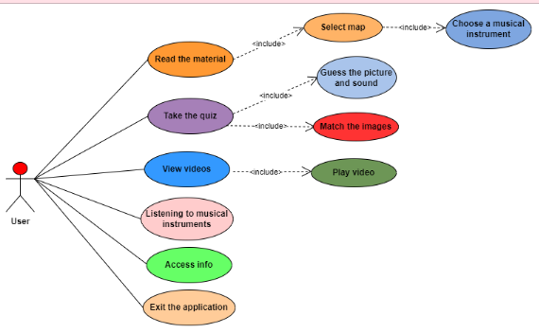

Figure 2. Use Case Diagram for Interactive Multimedia

Figure 2 shows the use case diagram of the interactive multimedia being developed. This use case diagram shows how the user interacts with the system. In this interactive multimedia, there is one actor and seven main use cases, as well as two use cases included in the material menu, two use cases included in the quiz menu, and one-use case included in the video menu.

1. Design Program

A basic framework and design are created using wireframes, which will be used in the Interactive Multimedia. These wireframes provide visual examples showing how the Multimedia will be structured, ensuring a clear understanding of the final product. The wireframe design of the application is shown in Figure 3 below.

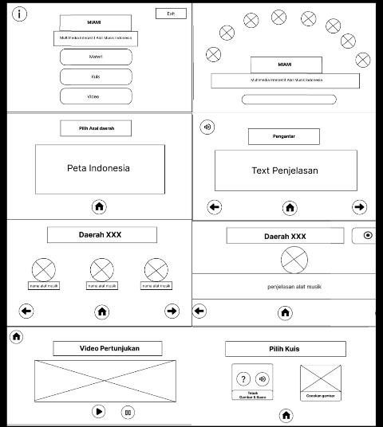

Figure 3. Wireframe Design of Application

1. Material Collecting

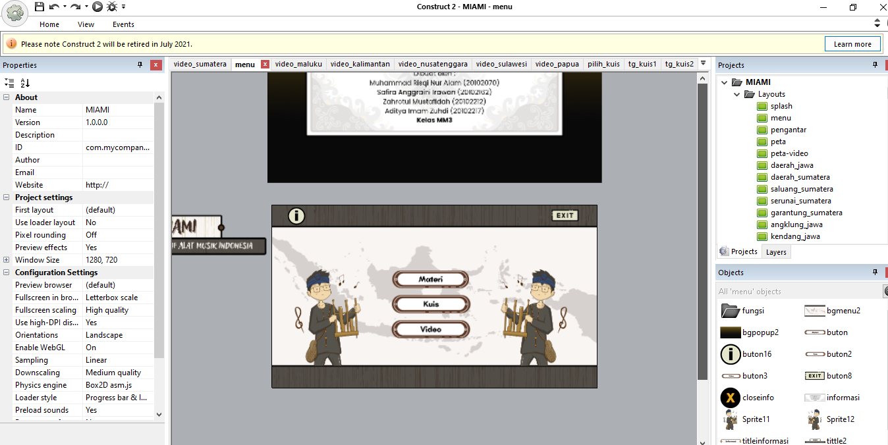

Figure 4. Combining Assets using Construct 2

Asset creation was made by utilizing Canva as the main design tool. Canva was used to create visual images that represent various traditional Indonesian musical instruments that will be presented in interactive multimedia. For images of musical instruments and characters using graphics available in Canva. As for the button design assets, page titles, display layouts were made manually, not using templates from Canva.

After the assets are collected, proceed with merging the assets using Construct 2. In this stage, the application of behavior elements, interactions between pages, transitions, and designing the placement of frames so that interactive multimedia applications provide an interesting user experience. It is intended that users can enjoy information about traditional Indonesian musical instruments with an attractive visual display, and the material can be conveyed properly.

1. Assembly

At this stage, researchers do the best possible interactive multimedia development in order to convey information about traditional Indonesian musical instruments to users. The following are the results of the development process.

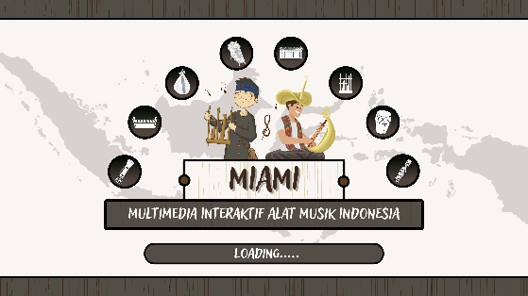

Figure 5. Splash Screen Page Interface

After the user opens the MIAMI (Interactive Multimedia of Indonesian Musical Instruments) interactive multimedia, the splash screen page will appear, on this page two cartoon characters are displayed playing traditional Indonesian musical instruments against the background of a world map. The character on the left plays the angklung, while the right character plays the flute. Around them, black icons depict various musical instruments. A sign reading "MIAMI" is located in the center of the screen with the tagline "INTERACTIVE MULTIMEDIA OF INDONESIA'S MUSICAL TOOLS".

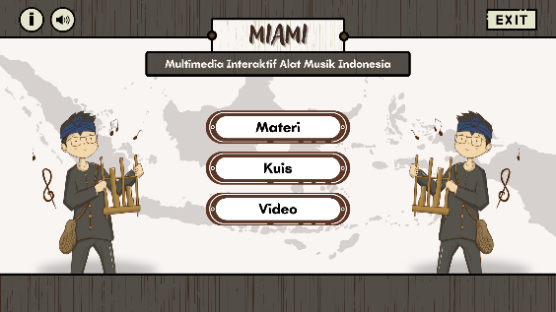

Figure 6. Home Interface

The main page will be designed with a page title at the top center, which is "MIAMI". Below the page title, there are three buttons that offer different content options, namely "Material", "Quiz", and "Video". in addition, there are Information and Exit buttons.

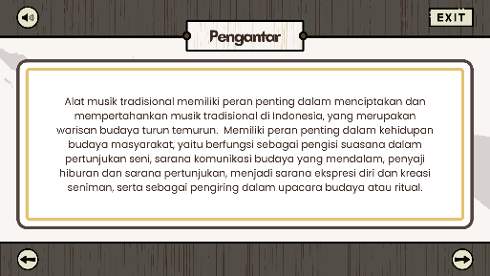

Figure 7. Introduction Page View

When the user selects the material button, they will be directed to the introduction page. This introductory page contains an introduction along with dubbing, which can be turned off by selecting the sound button.

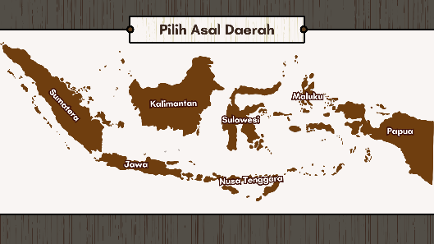

Figure 8. Map View Select Regional Origin

After passing the introduction, the user will be presented with a menu to select the origin of the region. In this menu, users can choose regions based on the big islands on the map to learn musical instruments that are in their respective regions. next when choosing one of the regions, for example the Java Region.

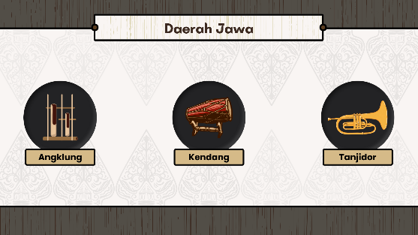

Figure 9. Display Types of Regional Musical Instruments

On this region page, the user will be presented with icons of the types of traditional musical instruments from the selected region, for example Java, namely Angklung, Kendang, and Tanjidor icons. If the user clicks on one of the musical instrument options, the system will display more information about the intended musical instrument.

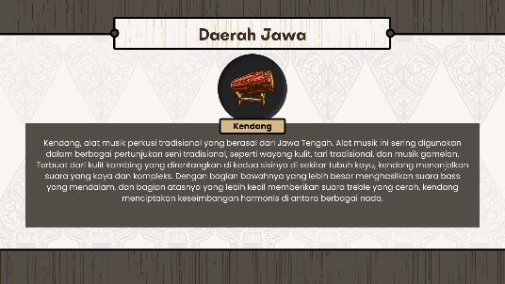

Figure 10. Musical Instrument Explanation Display

After the user selects one of the musical instruments, for example Kendang, the system will open the musical instrument explanation page. On this page, users will be presented with complete information about angklung, such as how to play, history, and related cultures. At the top of the page, there is a navigation bar that displays the name of the region and the name of the selected musical instrument. On the right side of the navigation bar, there is a stop button to stop the sound of the musical instrument.

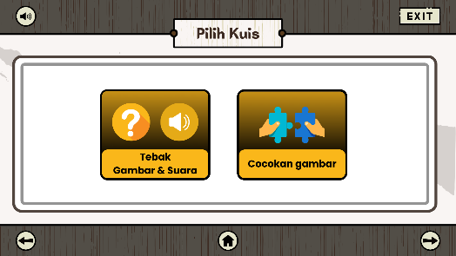

Figure 11. Quiz Menu Display

After the user selects the quiz menu, the system will display a page containing two quiz type options, namely "Tebak Gambar & Suara" and "Cocokkan gambar". On this page, users can select one of the quiz types they want to play by clicking the appropriate button. The "Guess Picture & Sound" button will direct users to a page containing a quiz involving pictures and sounds of traditional Indonesian musical instruments. Users will have to guess the name of the musical instrument being shown or heard. The "Match images" button will direct the user to a page containing a quiz involving images that must be matched. The user must match the image of the musical instrument with its name or region of origin.

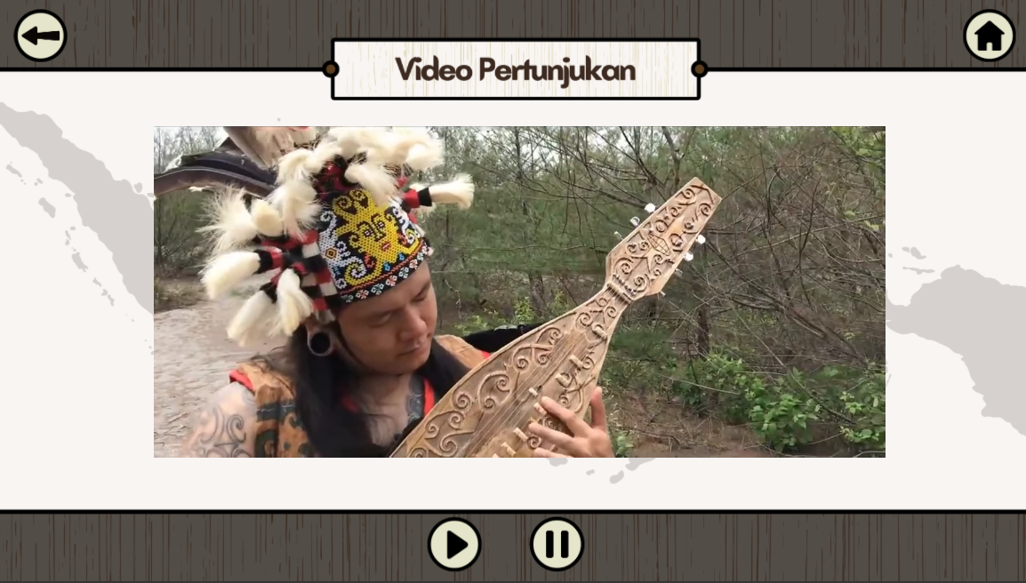

Figure 12. Performance Video Display

After the user selects a video button, the system will redirect the user to the performance video page. On this page, the user will be presented with videos showing performances of traditional Indonesian musical instruments from the selected region. There is a large area that displays the video. Below the video area, there are control buttons to play or pause the video. On the top left side, there is a home button to return to the main page.

1. Testing

At this stage, two tests were carried out, namely, Alpha Testing is an internal test conducted by the researchers themselves to ensure that the product or service is functioning properly. Furthermore, beta testing is an external test conducted by users to get feedback on the product or service through a questionnaire.

Alpha Testing

In this test, testing was carried out on the appearance and function of each button in the interactive multimedia of Indonesian musical instruments as in Table 1.

Table 1. Alpha Testing

|  |  |  |  |  |
| --- | --- | --- | --- | --- |
| **No** | **Components tested** | **Test Scenarios** | **Testing** | **Information** |
| 1 | Home | "Materials" button | BlackBox | Succeed |
|  |  | "Quiz"  button | BlackBox | Succeed |
|  |  | "Video"  button | BlackBox | Succeed |
|  |  | "Information"  button | BlackBox | Succeed |
|  |  | “Exit”  button | BlackBox | Succeed |
| 2 | Material Introduction Page | "Sound-on"  button | BlackBox | Succeed |
|  |  | "Sound-off"  button | BlackBox | Succeed |
|  |  | "Back"  button | BlackBox | Succeed |
|  |  | "Next"  button | BlackBox | Succeed |
|  |  | "Home"  button | BlackBox | Succeed |
| 3 | Material Page | "Original  Map of Java District" button | BlackBox | Succeed |
|  |  | "Angklung Musical Instrument" button | BlackBox | Succeed |
|  |  | "Kendang Musical Instrument" button | BlackBox | Succeed |
|  |  | "Tanjidor Musical Instrument"  button | BlackBox | Succeed |
|  |  | "Listening to a Musical Instrument" button | BlackBox | Succeed |
|  |  | "Stop" button | BlackBox | Succeed |
|  |  | "Home" button | BlackBox | Succeed |
|  |  | "Back" button | BlackBox | Succeed |
|  |  | "Next" | BlackBox | Succeed |
| 4 | Quiz Page | button  "Guess the Image &; Sound" | BlackBox | Succeed |
|  |  | button  "Image Match" | BlackBox | Succeed |
|  |  | button  "Quiz Answers" | BlackBox | Succeed |
|  |  | button  "Sound-on" | BlackBox | Succeed |
|  |  | button  "Sound-off" | BlackBox | Succeed |
|  |  | button  "Close Skor Chaste" | BlackBox | Succeed |
|  |  | button  "Close Skor Chaste" button | BlackBox | Succeed |
|  |  | “Next" button | BlackBox | Succeed |
|  |  | "Back" button | BlackBox | Succeed |
|  |  | "Home" button | BlackBox | Succeed |
| 5 | Video Page | "The Original Map of Java District" button | BlackBox | Succeed |
|  |  | “Play" button | BlackBox | Succeed |
|  |  | "Pause" button | BlackBox | Succeed |
|  |  | "Back" button | BlackBox | Succeed |
|  |  | "Home" button | BlackBox | Succeed |

Based on Table 1. five tests were carried out on the features in the interactive multimedia, each component can run well without any errors.

Beta Testing

In the beta testing stage, the interactive multimedia that has been developed is tested by 36 respondents through Google Form. Processing the results of the questionnaire through Beta Testing helped reveal the extent of the feasibility and response of the interactive multimedia. With 14 assessment indicators and a five-value scale, this evaluation provides a clearer picture of how this solution meets the user's needs and desired learning objectives. for the value scale is as follows.

Strongly Disagree (STS) = 1

Disagree (TS) = 2

Neutral (N) = 3

Agree (S) = 4

Strongly Agree (SS) = 5

For example, indicator 1 is "The visual appearance of multimedia is attractive and pleasant".

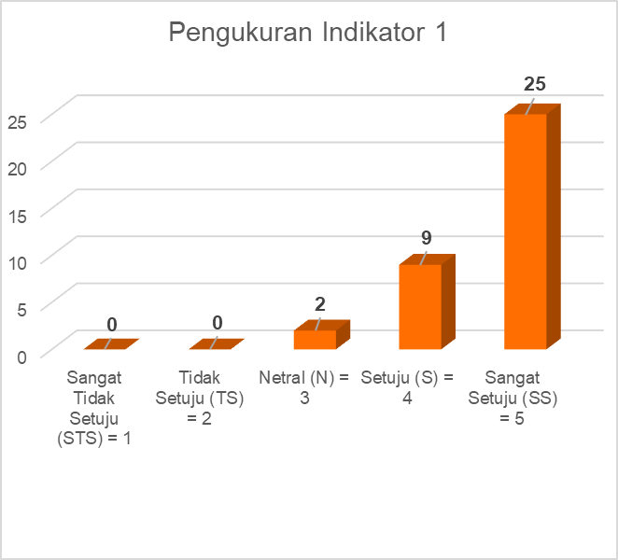

Figure 13. Measurement of Indicator 1

In this figure, it was found that 25 respondents gave a score of strongly agree, 9 respondents agreed, 2 respondents were neutral, then no respondents filled in disagree, strongly disagree. From these results, a rating calculation is carried out for indicator 1, with the following calculations.

Strongly Disagree= 1 * 0 = 0

Disagree = 2 * 0 = 0

Neutral = 3 * 2 = 6

Agree = 4 * 9 = 36

Strongly Agree = 5 * 25 = 125

Total = 167

Rating = 167/36

= 4,64

Rating calculations on other indicators were also carried out with the following results.

Table 2. Assessment Rating

|  |  |  |
| --- | --- | --- |
| **No** | **Indicator** | **Value** |
| 1 | Indicator 1 | 4,64 |
| 2 | Indicator 2 | 4,44 |
| 3 | Indicator 3 | 4,61 |
| 4 | Indicator 4 | 4,53 |
| 5 | Indicator 5 | 4,56 |
| 6 | Indicator 6 | 4,50 |
| 7 | Indicator 7 | 4,64 |
| 8 | Indicator 8 | 4,56 |
| 9 | Indicator 9 | 4,31 |
| 10 | Indicator 10 | 4,33 |
| 11 | Indicator 11 | 4,61 |
| 12 | Indicator 12 | 4,61 |
| 13 | Indicator 13 | 4,44 |
| 14 | Indicator 14 | 4,50 |
| Total = 63,28 / 14 = 4,52 | | |

From the evaluation results, the score obtained is 4.52 on a scale of 5 indicating that the interactive multimedia that has been made is feasible to use as information media about traditional Indonesian musical instruments at this time.

Distribution

Once testing has been successfully completed, the application is ready for publication. The publication process is done through the itch.io platform, where interactive multimedia can be accessed and played on users' computer and mobile devices through the following link https://zahromstfd.itch.io/miami.

# CONCLUSION

From the results of this study, it can be concluded that the application of the Multimedia Development Life Cycle (MDLC) method in the development of interactive multimedia introduction to traditional Indonesian musical instruments provides positive results. The stages of MDLC, namely Concept, Design, Material Collecting, Assembly, Testing, and Distribution, proved to be able to produce an attractive and educational information media.

Alpha testing shows that all features in this interactive multimedia function properly. This gives confidence that users can access information about traditional Indonesian musical instruments smoothly through this application. The research focus on the lack of interactive multimedia-based educational information media about traditional musical instruments was successfully overcome by making this interactive multimedia. Through beta testing involving 36 respondents, a rating of 4.52 on a scale of 5 was obtained. This confirms that this interactive multimedia is very good and feasible to use as a learning medium, especially for children who need an interesting and educational approach.

Thus, this interactive multimedia can be an effective solution in providing an understanding and introduction to the diversity of Indonesian traditional musical instruments to the wider community, as well as answering the need for interesting and informative learning media**.**

**REFERENCE**

[1] S. Muhajaroh, A. P. Kurniawan, and Y. Siradj, “Perancangan Model 3D Dan Sound Untuk Aplikasi Interaktif Pengenalan Alat Musik Tradisional Berbasis Augmented Reality,” *e-Proceeding of Applied Science*, pp. 4307-4315, vol.6, No.2 Desember 2020.

[2] D. Aldo, M. Ilmi, and H. Hariselmi, “Pengembangan Multimedia Interaktif Hewan Berbisa dengan Metode Multimedia Development Life Cycle,” *Journal of Information System Research (JOSH)*, vol. 4, no. 2, pp. 364–373, Jan. 2023, doi: 10.47065/josh.v4i2.2669.

[3] D. Joana Laksana, A. Budiman, and W. Apriandari, “Game Edukasi Pengenalan Alat Musik Tradisional Menggunakan Metode MDLC Berbasis Android,” *Jurnal Ilmiah Teknik Informatika dan Sistem Informasi*, Jutisi, vol. 10, No. 1, April 2021: hal. 45-56.

[4] W. T. Atmojo, F. Fitri Nurwidya, and E. Dazki, “Media Pembelajaran Pengenalan Keragaman Budaya Indonesia Dengan Metode Multimedia Development Life Cycle.” *Seminar Nasional APTIKOM (SEMNASTIK),* 2019, hal 126-134.

[5] D. Basmin, “MEDIA PEMBELAJARAN GAME EDUKASI MENGENAL ALAT MUSIK TRADISIONAL INDONESIA DI SDN 249 TURUNGAN DATU,” *Jurnal Ilmiah Information Technology d’Computare,* vol 12, hal 19-24, Januari. 2022.

[6] M. Baihaiki, “Implementasi Game Edukasi Kesenian Budaya Indonesia Berbasis Dekstop dengan Metode MDLC pada SDS Harapan Jaya Jakarta Barat,” *Jurnal Sosial dan Teknologi (SOSTECH)*, vol. 1, no. 7, 2021, [Online]. Available: https://greenvest.co.id/

[7] D. A. Asmara, G. Susilo, and M. Lutfi Mahasinul, “APLIKASI PENGENALAN ALAT MUSIK GAMELAN JAWA,” *Jurnal TRANSFORMASI*, vol. 16, no. 1, pp. 43–53, 2020.

[8] W. T. Atmojo, F. Fitri Nurwidya, and E. Dazki, “Media Pembelajaran Pengenalan Keragaman Budaya Indonesia Dengan Metode Multimedia Development Life Cycle.” *Seminar Nasional APTIKOM (SEMNASTIK),* 2019, hal 126-134.

[9] B. Widiyanto *et al.*, “PENGENALAN TUJUH KEAJAIBAN DUNIA MELALUI AUGMENTED REALITY SEBAGAI EDUKASI ANAK USIA DINI BERBASIS MOBILE.” *JIPI (Jurnal Ilmiah Penelitian dan Pembelajaran Informatika),* vol 06, Nomor 02, Desember 2021 : 196 – 204.

[10] A. Z. Shoumi, “PERAN MULTIMEDIA DALAM PENDIDIKAN PADA APLIKASI RUANG GURU,” *PROSIDING SEMINAR NASIONAL CENDEKIAWAN*, Oct. 2019, doi: 10.25105/semnas.v0i0.5809.

[11] A. nisa N. S. Indah Septiani, I. Septiani, T. Rejekiningsih, Triyanto, and Rusnaini, “*Development of interactive multimedia learning courseware to strengthen students’ character,”* *European Journal of Educational Research*, vol. 9, no. 3, Jul. 2020, doi: 10.12973/eu-jer.9.3.1267.

[12] W. Z. Rayhan and S. Wulandari, “*MOBILE AUGMENTED REALITY APPLICATION (ARFABICS) OF HIJAIYAH LETTER INTRODUCTION AS LEARNING MEDIA FOR CHILDREN,*” *JIKO (Jurnal Informatika dan Komputer)*, vol. 6, no. 3, pp. 174–181, Dec. 2023, doi: 10.33387/jiko.v6i3.6832.

[13] N. A. Suryandaru, “PENERAPAN MULTIMEDIA DALAM PEMBELAJARAN YANG EFEKTIF,” *Jurnal Pendidikan dan Pengajaran Guru Sekolah Dasar (JPPGuseda)*, vol. 03, pp. 88–91, 2020, [Online]. Available: http://journal.unpak.ac.id/index.php/jppguseda

[14] H. Anggreani and P. Rosyani, “Perancangan Aplikasi Pengenalan Jenis - Jenis Dinosaurus Pada Anak - Anak Usia Dini Berbasis Flash,” *KERNEL: Jurnal Riset Inovasi Bidang Informatika dan Pendidikan Informatika*, vol. 2, no. 2, pp. 77–81, Feb. 2022, doi: 10.31284/j.kernel.2021.v2i2.2293.

[15] A. G. Pradana and S. Nita, “Rancang Bangun Game Edukasi ‘AMUDRA’Alat Musik Daerah Berbasis Android,” 2019. e-ISSN: 2685-5615, hal 49-53.

[16] L. Novia and D. Zalilludin, “Aplikasi Media Pembelajaran Mengenal Alat Musik Tradisional Untuk Anak-Anak Berbasis Augmented Reality Pada Perangkat Mobile,” Jurnal IKRA-ITH Informatika, Vol 5 No 1 Maret 2021.